Web Systems Programming

CS Tools Proposal

Shaun Mueller - 13171256

# Purpose of the Site

The purpose of the website that I will be creating is to allow customers to learn about CS Tools, browse their products, contact CS Tools, and place orders online.

The website will also allow CS Tools administrators to login, where they will be able to view and update their customers details, their orders, and their stock.

This is made possible by linking the website to the MySQL database using PHP.

# Target Audience

The target audience for the CS Tools website is both the customers and the administrators.

Customers will typically be early to middle aged IT professionals or enthusiasts.

The administrators will be employees of CS Tools who need to access their database to look up or update their customer, orders, or stock records.

# Site Map

* Only viewable by logged in administrators.

# Layout

**Index**

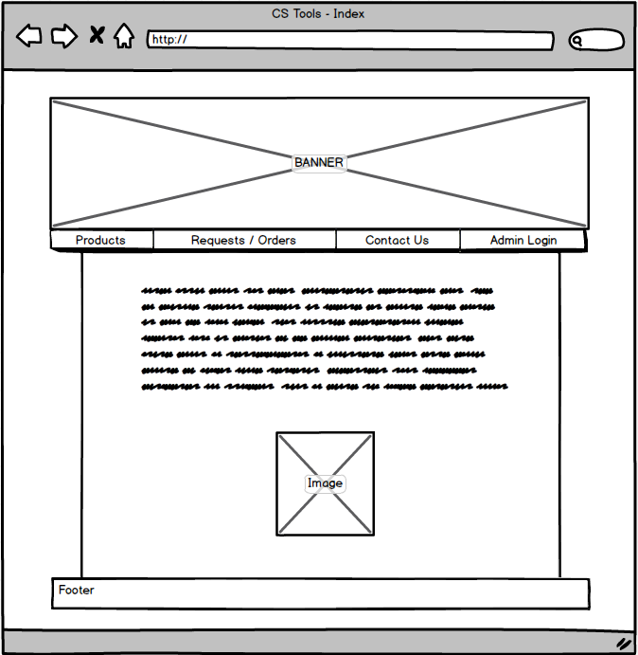

The index page is kept simple, featuring the CS Tools banner, a horizontal list of links for navigation, a description about CS Tools, an image, and a footer giving credit to the web designer.

**Admin Index**

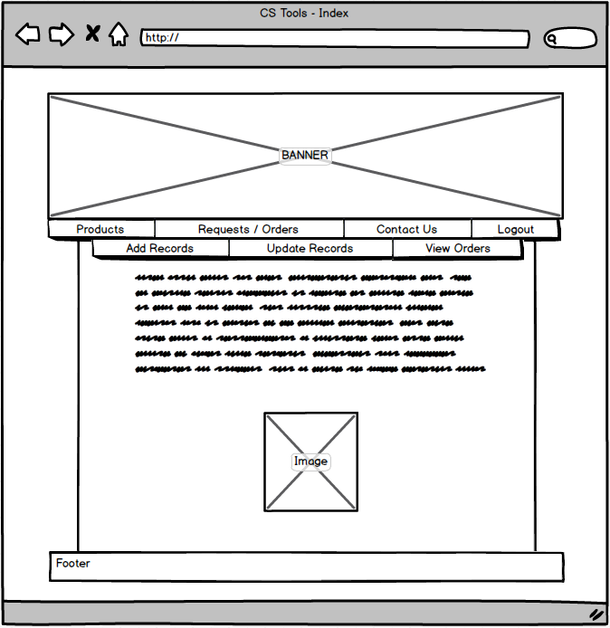

The admin index will be the same page as the regular index, but it will contain PHP if statements to determine whether an admin is logged in. When this is the case, another horizontal list of admin-only links will be displayed.

**Contact Us**

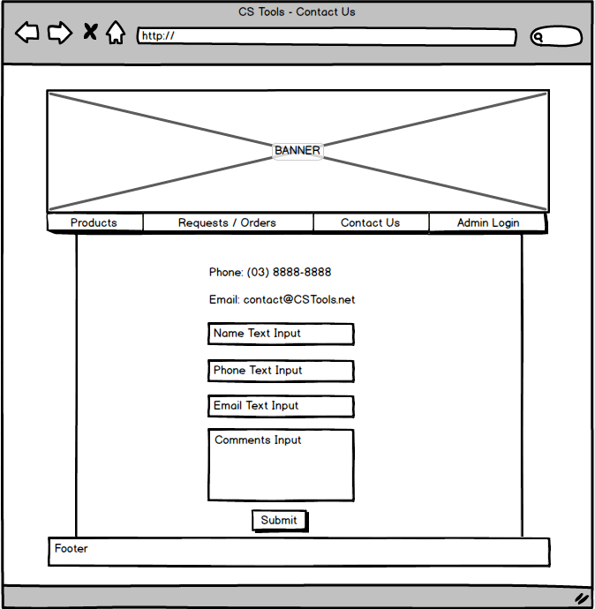

The contact us page will include contact details for CS Tools, as well as a form customers can fill in and submit.

**Products**

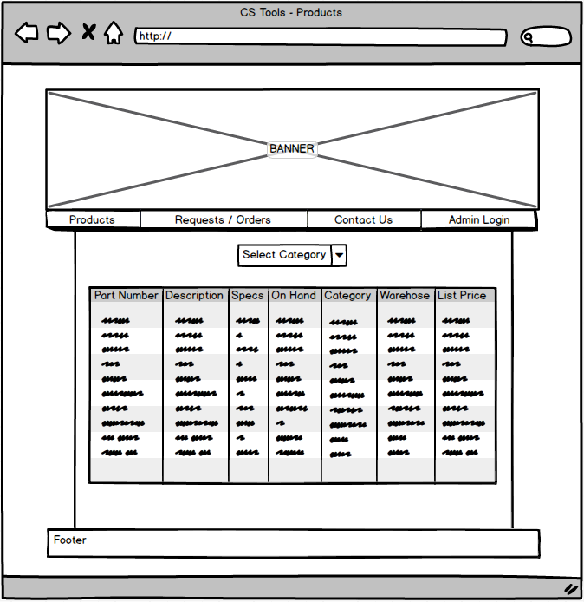

The products page will start off by displaying all available products. It will contain a drop-down box at the top of the page, which the customer can use to filter the products by category.

**Add / Update Records (admin only)**

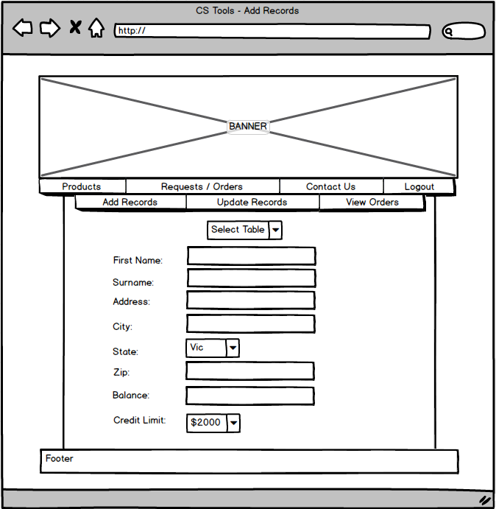

The add records and update records pages will be separate, however they will look very similar. They will contain a drop-down box at the top to determine which table is being used. An appropriate form with input fields will then be displayed depending on which table was selected. A submit button (not shown in graphic) will be placed at the end of the form. Clicking the submit button will add a record to or update the database.

# Interface Design

The interface design is minimalistic focusing on a black and green theme. Content will be featured in an off-white section which is easier on the eyes than a pure white colour.

**Index**

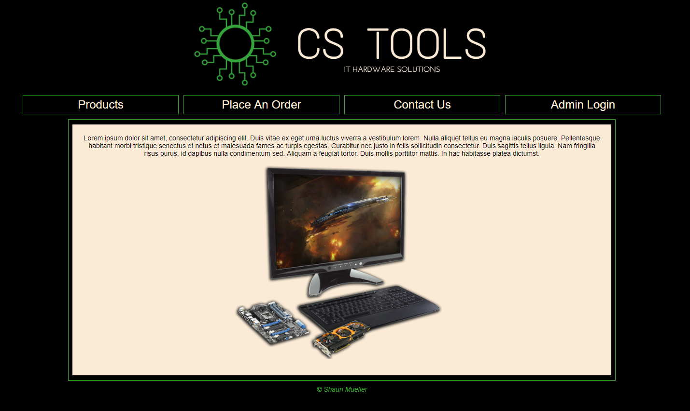

**Index featuring admin links**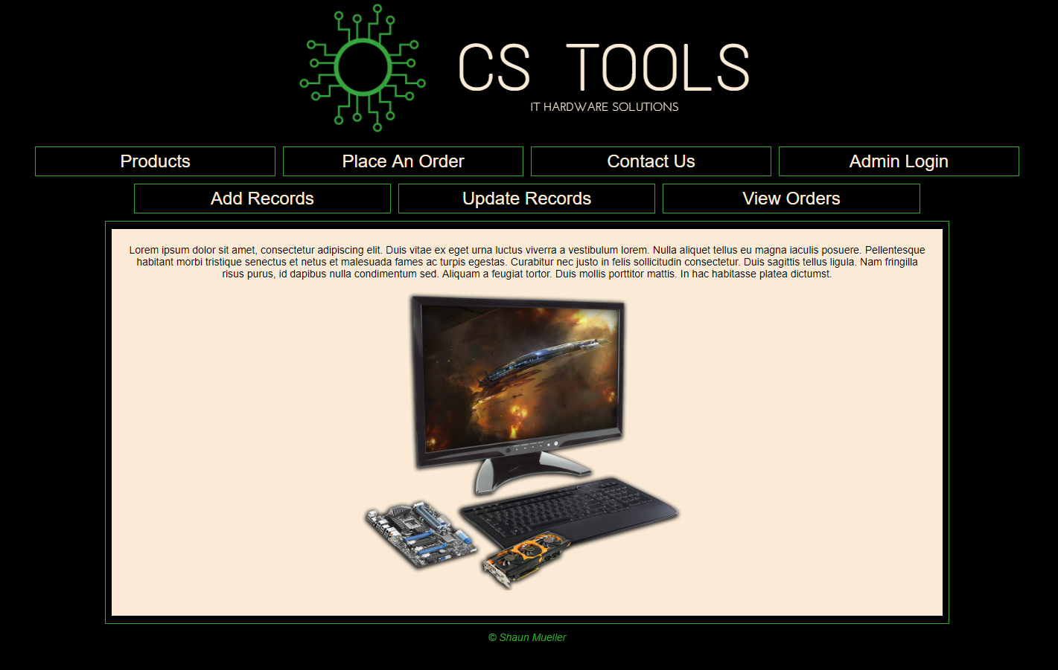

# Data Dictionary

**Database Structure**

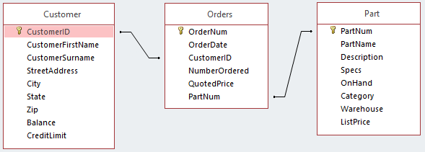

The database is structured so that the CustomerID and PartNum fields from the Customer and Part tables respectfully, are used to create a relationship with the Orders table.

**Customer Table**

|  |  |  |  |  |
| --- | --- | --- | --- | --- |
| Field Name | Required | Type | Length | Notes |
| CustomerID | Yes | INT | n/a | Primary Key.  Auto increments from 1. |
| CustomerFirstName | No | CHAR | 30 |  |
| CustomerSurname | No | CHAR | 30 |  |
| StreetAddress | No | CHAR | 100 |  |
| City | No | CHAR | 30 |  |
| State | No | CHAR | 30 |  |
| Zip | No | INT | n/a |  |
| Balance | No | FLOAT | n/a |  |
| CreditLimit | No | FLOAT | n/a |  |

**Orders Table**

|  |  |  |  |  |
| --- | --- | --- | --- | --- |
| Field Name | Required | Type | Length | Notes |
| OrderNum | Yes | INT | n/a | Primary key.  Auto increments from 8001. |
| OrderDate | No | DATE | n/a | YYYY-MM-DD format. |
| CustomerID | Yes | INT | n/a | Foreign key with CustomerID from Customer table. |
| NumberOrdered | No | INT | n/a |  |
| QuotedPrice | No | FLOAT | n/a |  |
| PartNum | Yes | INT | n/a | Foreign key with PartNum from Part table. |

**Part Table**

|  |  |  |  |  |
| --- | --- | --- | --- | --- |
| Field Name | Required | Type | Length | Notes |
| PartNum | Yes | INT | n/a | Primary key.  Auto increments from 601. |
| PartName | No | CHAR | 100 |  |
| Description | No | CHAR | 200 |  |
| Specs | No | CHAR | 200 |  |
| OnHand | No | INT | n/a |  |
| Category | No | CHAR | 50 |  |
| Warehouse | No | CHAR | 50 |  |
| ListPrice | No | FLOAT | n/a |  |

The database can be manipulated via the CS Tools website. An administrator can log in to view, add, and update entries.

|  |  |  |  |  |
| --- | --- | --- | --- | --- |
| Requirement | Initiated | Condition | Displayed result | Page-Name |
| Navigation links | Links in a horizontal unordered list | Link Clicked | Opens the corresponding webpage. | Every page. |
| Contact Us Feedback | Form with validation | Submit button clicked | Redirects to “thank you” page, then after 5 second redirects back to index. | contact.php |
| Products (all products & by category) | Page load (all products) & drop-down list selection (specific category of products) | Category selected from drop-down list | Displays entries from Part table in html table. | products.php |
| Place Orders | Form with validation | Submit button clicked | Redirects to “thank you” page, then after 5 second redirects back to index. | customerRequest.php |
| Admin Login | Form | Login button clicked | If successful, redirects to index with admin links visible. If failure, displays “login fail” message. | admin_Login.php |
| Admin Logout | Link | Link clicked | Ends session & redirects to index with admin links hidden. | logout.php |
| Admin Add Records | Form | Submit button clicked | If successful, adds record to database and displays an “entry added” message. If failure, displays error message. | admin_AddRecords.php |
| Admin Update Records | Form | Submit button clicked | If successful, updates record in database and displays a “entry updated” message. If failure, displays error message. | admin_UpdateTables.php |
| Admin view orders | Form | Submit button clicked | Displays the specified order in a html table. | admin_ViewOrders.php |